# Lab: CSS Positioning

Problems for exercises and homework for the ["HTML and CSS" course @ SoftUni](https://softuni.bg/courses/web-fundamentals-html5). Submit your solutions in the SoftUni judge system at <https://judge.softuni.bg/Contests/800/Lab-CSS-Positioning>.

## Social Media

Create a Web Page like the following.

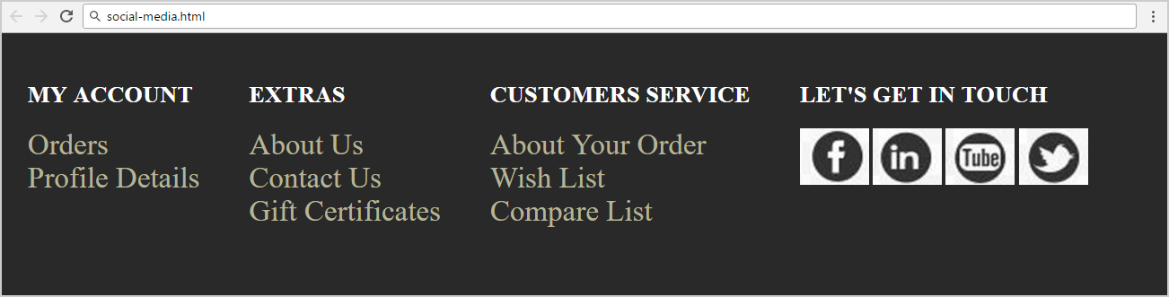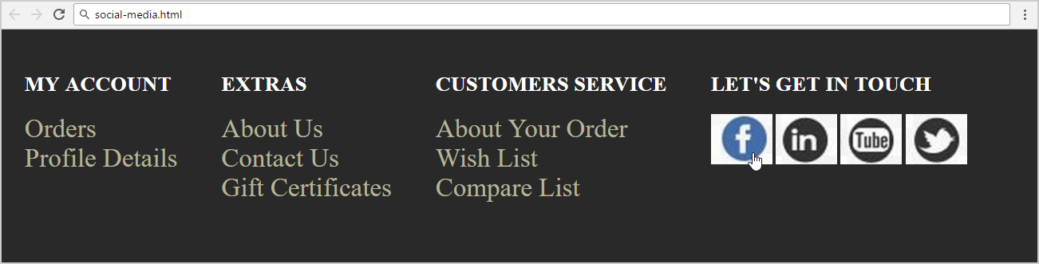

Create files: "**social-media.css**" and "**social-media.html**"

### Constrains

Use **Semantic tags**

## Drop Down Menu

Create a Web Page like the following.

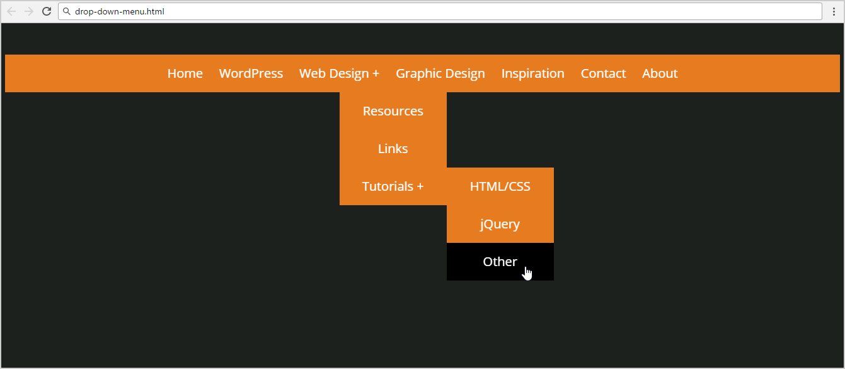

Create files: "**drop-down-menu.css**" and "**drop-down-menu.html**"

Default font: **"Open Sans", sans-serif**

[**http://fonts.googleapis.com/css?family=Open+Sans**](http://fonts.googleapis.com/css?family=Open+Sans)

Text Color: **#ffffff;**

Background Color: **#1d211e, #e67c1f**

### Constrains

* Default font-size: **22px**

## Floating Elements

Create a Web Page like the following.

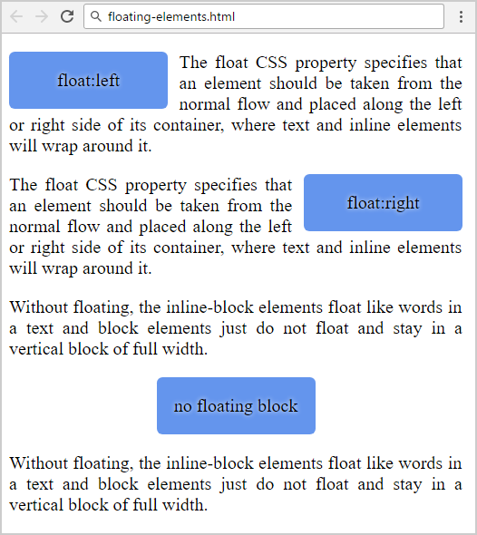

Create files: "**floating-elements.css**" and "**floating-elements.html**"

Use **Semantic tags**

### Constrains

Use **Divs** with class **left, center and right** to display the floated elements.

Use **Paragraphs** for text.

## Clear Floating

Create a Web Page like the following.

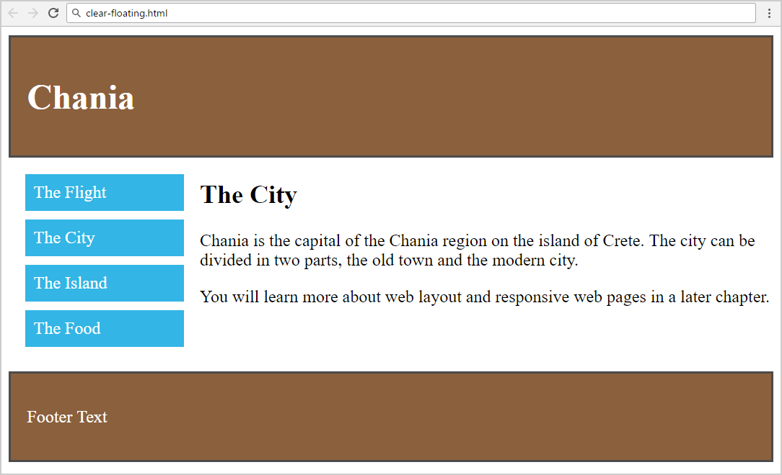

Create files: "**clear-floating.css**" and "**clear-floating.html**"

Use **Semantic tags**

### Constrains

Use **float left** and **float right** + **clear the float**.

Use **Main** with class **clearfix**.